BÀI TẬP TỔNG HỢP VỀ CÁC THÌ TRONG TIẾNG ANH
EXERCISE 1: Use the correct form of verbs in brackets.
1. In all the world, there (be) __________ only 14 mountains that (reach) __________above 8,000 meters.
2. He sometimes (come) __________ to see his parents.
3. When I (come) __________, she (leave) __________for Dalat ten minutes ago.
4. My grandfather never (fly) __________ in an airplane, and he has no intention of ever doing so.
5. We just (decide) __________ that we (undertake) ____________ the job.
6. He told me that he (take) __________ a trip to California the following week.
7. I knew that this road (be) __________ too narrow.
8. Right now I (attend) __________ class. Yesterday at this time I (attend) __________class.
9. Tomorrow I’m going to leave for home. When I (arrive) __________at the airport, Mary (wait) __________ for me.
10. Margaret was born in 1950. By last year, she (live) __________on this earth for 55 years.
11. The traffic was very heavy. By the time I (get) __________to Mary’s party, everyone already (arrive) __________
12. I will graduate in June. I (see) __________ you in July. By the time I (see) __________ you, I (graduate) __________.
13. I (visit) __________ my uncle’s home regularly when I (be) __________ a child.
14. That book (be) __________ on the table for weeks. You (not read) __________ it yet?
15. David (wash) __________ his hands. He just (repair) __________ the TV set.
16. You (be) __________here before? Yes, I (spend) __________ my holidays here last year.
17. We never (meet) __________ him. We don’t know what he (look) __________ like.
18. The car (be) __________ ready for him by the time he (come) __________tomorrow.
19. On arriving at home I (find) __________that she just (leave) __________a few minutes before.
20. When we (arrive) __________ in London tonight, it probably (rain) __________.
21. It (rain) __________ hard. We can’t do anything until it (stop) __________
22. Last night we (watch) __________TV when the power (fail) __________.
23. That evening we (stay) __________up to talk about the town where he (live) __________for some years.
24. I (sit) __________down for a rest while the shoes (repair) __________.
25. Half way to the office Paul (turn) __________round and (go) __________back home because he (forget) __________to turn the gas off.
26. London (change) __________a lot since we first (come) __________ to live here.
27. While we (talk) __________on the phone the children (start) __________fighting and (break) __________a window
28. He used to talk to us for hours about all the interesting things he (do) __________ in his life.
29. You know she (stand) __________looking at that picture for the last twenty minutes.
30. I (spend) __________ a lot of time travelling since I (get) __________this new job.
31. When we (be) __________ at school we all (study) __________Latin.
32. When I (meet) __________ him, he (work) __________as a waiter for a year.
33. After he (finish) __________ breakfast he (sit) __________down to write some letters.
34. She (have) __________a hard life, but she’s always smiling.
35. I think Jim (be) __________ out of town.
EXERCISE 2: Choose the best answer among A, B, C, or D.
1. When I last saw him, he _____ in London.
A. has lived B. is living C. was living D. has been living
2. We _______ Dorothy since last Saturday.
A. don’t see B. haven’t seen C. didn’t see D. hadn’t seen
3. The train ______ half an hour ago.
A. has been leaving B. left C. has left D. had left
4. Jack ______ the door.
A. has just painted B. paint C. will have painted D. painting
5. My sister ________ for you since yesterday.
A. is looking B. was looking C. has been looking D. looked
6. I ______ Texas State University now.
A. am attending B. attend
C. was attending D. attended
7. He has been selling motorbikes ________.
A. ten years ago B. since ten years C. for ten years ago D. for ten years
8. Christopher Columbus _______ American more than 500 years ago.
A. discovered B. has discovered C. had discovered D. had been discovering
9. He fell down when he ______ towards the church.
A. run B. runs C. was running D. had run
10. We _______ there when our father died.
A. still lived B. lived still C. was still lived D. was still living
11. They ______ table tennis when their father comes back home.
A. will play B. will be playing C. play D. would play
12. By Christmas, I _______ for Mr. Smith for six years.
A. will have been working B. will work C. have been working D. will be working
13. I _______ in the room right now.
A. am being B. was being C. have been being D. am
14. I ______ to New York three times this year.
A. have been B. was C. were D. had been
15. I’ll come and see you before I _______ for the States.
A. leave B. will leave C. have left D. shall leave
16. The little girl asked what _______ to her friend.
A. has happened B. happened
C. had happened D. would have been happened
17. John ______ a book when I saw him.
A. is reading B. read C. was reading D. reading
18. He said he _______ return later.
A. will B. would C. can D. would be
19. Jack ________ the door.
A. has just opened B. open
C. have opened D. opening
20. I have been waiting for you ______ .
A. since early morning B. since 9 a.m
C. for two hours D. All are correct
21. Almost everyone _______ for home by the time we arrived.
A. leave B. left C. leaves D. had left
22. By the age of 25, he ______ two famous novels.
A. wrote B. writes C. has written D. had written
23. When her husband was in the army, Mary ______ to him twice a week.
A. was reading B. wrote C. was written D. had written
24. I couldn’t cut the grass because the lawn mower ______ a few days previously.
A. broke down B. has been broken
C. had broken down D. breaks down
25. I have never played badminton before. This is the first time I _____ to play.
A. try B. tried C. have tried D. am trying
26. Since _______, I have heard nothing from him.
A. he had left B. he left C. he has left D. he was left
27. After I _______ lunch, I looked for my bag.
A. had B. had had C. have has D. have had
28. By the end of next year, George _______ English for two years.
A. will have learned B. will learn
C. has learned D. would learn
29. The man got out of the car, ________ round to the back and opened the book.
A. walking B. walked C. walks D. walk
30. Henry _______ into the restaurant when the writer was having dinner.
A. was going B. went C. has gone D. did go
31. He will take the dog out for a walk as soon as he ______ dinner.
A. finish B. finishes C. will finish D. finishing
32. I will be glad if he _______ with us.
A. had gone B. did go C. went D. goes
33 Ask her to come and see me when she _______ her work.
A. finish B. has finished C. finished D. finishing
34. Turn off the gas. Don’t you see that the kettle ________ ?
A. boil B. boils C. is boiling D. boiled
35. Tom and Mary ______ for Vietnam tomorrow.
A. leave B. are leaving C. leaving D. are left
36. He always ________ for a walk in the evening.
A. go B. is going C. goes D. going
37. Her brother ______ in Canada at present.
A. working B. works C. is working D. work
38. I ______ to the same barber since last year.
A. am going B. have been going C. go D. had gone
39. Her father ______ when she was a small girl.
A. dies B. died C. has died D. had died
40. Last week, my professor promised that he ________ today.
A. would come B. will come C. comes D. coming
EXERCISE 3: Choose the underlined part in each sentence (A, B,C, or D ) that needs correcting.
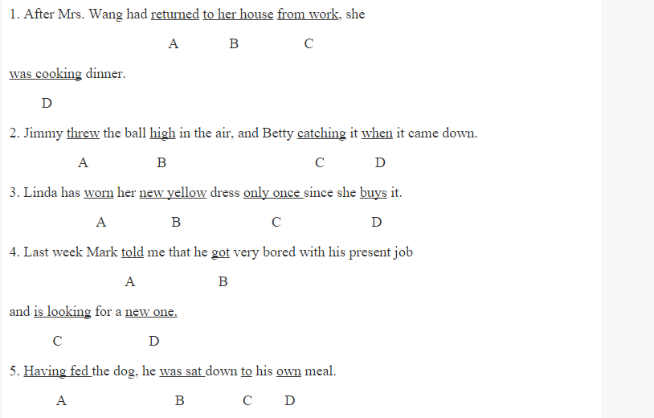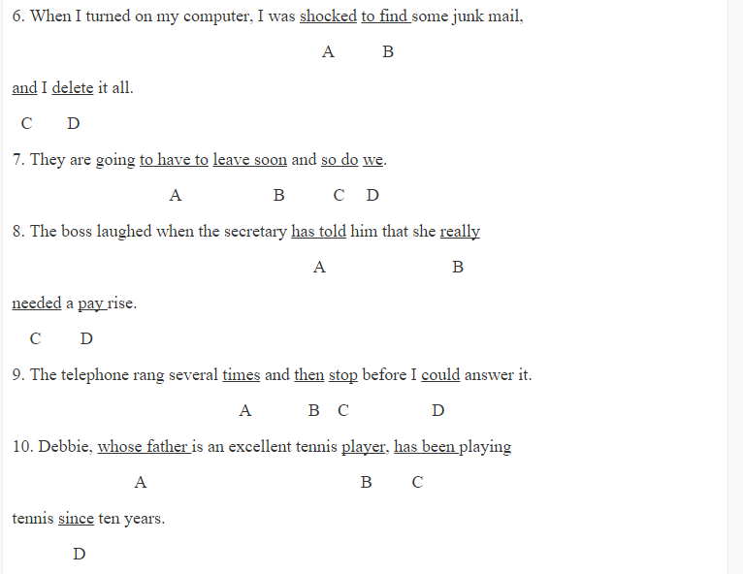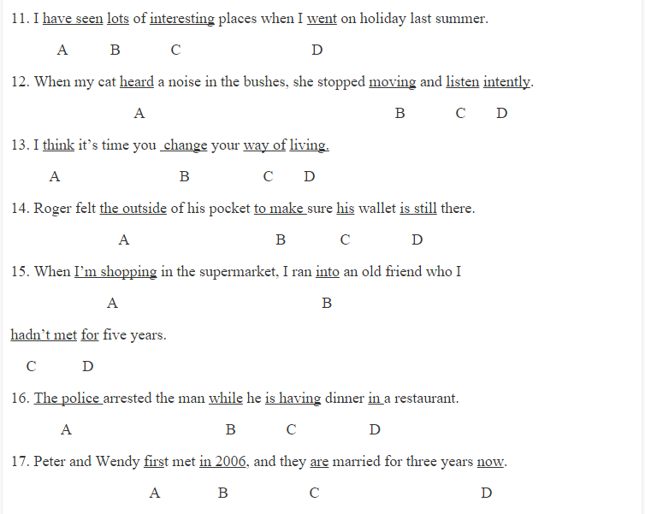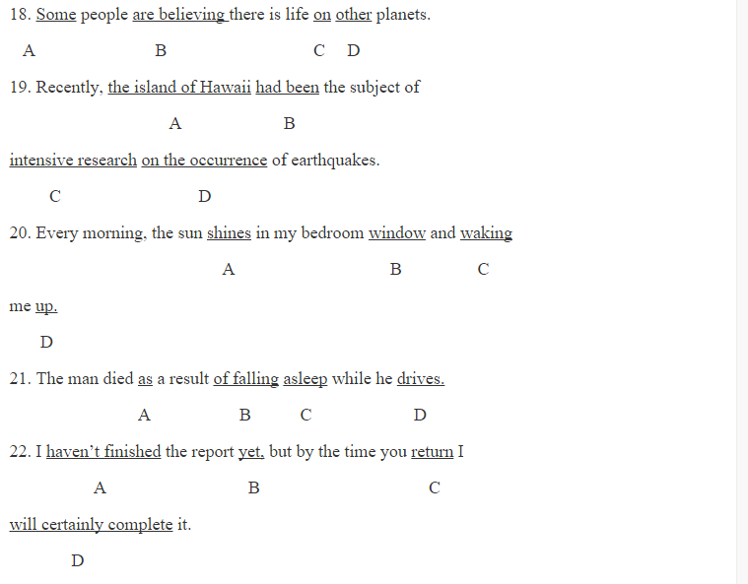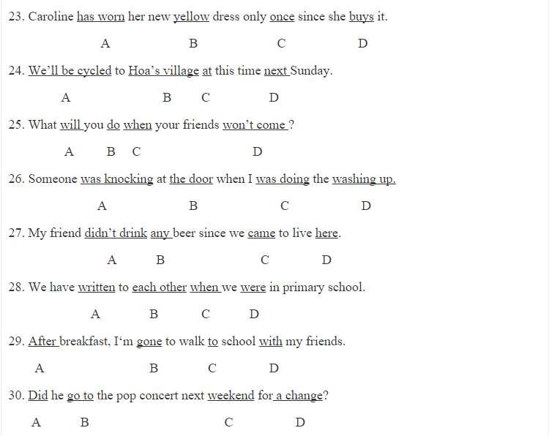
EXERCISE 4: Choose the correct sentence among A, B, C or D which has the same meaning as the given one.
1. Eight years ago we started writing to each other.
A. We have rarely written to each other for eight years.
B. Eight years is a long time for us to write to each other.
C. We wrote to each other eight years ago.
D. We have been writing to each other for eight years.

2. The boy was so lazy that he couldn’t stay up late to learn his lessons.
A. The boy was lazy enough not to stay up late to learn his lessons.
B. The boy was too lazy to stay up late to learn his lessons.
C. The boy was lazy enough but he stayed up late to learn his lessons.
D. The boy was lazy enough to stay up late to learn his lessons.

3. My father is tired of seeing any violent films.
A. My father hasn’t seen a violent film.
B. My father has enjoyed all the violent films he has ever seen.
C. My father is worried about missing the next violent film.
D. My father never wants to see another violent film.

4. As soon as he waved his hand, she turned away.
A. He saw her turn away and he waved his hand.
B. No sooner had he waved his hand than she turned away.
C. She turned away because he waved his hand too early.
D. Although she turned away, he waved his hand.

5. John wishes he had remembered to send Mary a Christmas card.
A. John regrets not to send Mary a Christmas card.
B. John regrets forgetting not to send Mary a Christmas card.
C. John regrets not remembering sending Mary a Christmas card.
D. John regrets forgetting to send Mary a Christmas card.

6. My father hasn’t smoked cigarettes for a month.
A. It’s a month since my father last smoked cigarettes.
B. It’s a month ago that my father smoked cigarettes.
C. It’s a month that my father hasn’t smoked cigarettes.
D. It’s a cigarette that my father smoked a month ago.

7. Having finished their work, the workers expected to be paid.
A. The workers expected to be paid because they had finished their work.
B. Having their work finishing, the workers expected to be paid.
C. Having expected to be paid, the workers finished their work.
D. Having been finished their work, the workers expected to be paid.

8. Mr. Brown bought this car five years ago.
A. Mr. Brown started to buy this car for five years.
B. It has been five years when Mr. Brown has bought this car.
C. Mr. Brown has had this car for five years.
D. It is five years ago since Mr. Brown has bought this car.

9. John used to write home once a week when he was abroad.
A. John doesn’t write home once a week any longer.
B. John enjoyed being written home every week when he was abroad.
C. John never forgot to write a weekly letter home when he was abroad.
D. When he was abroad he remembered to write home every week.

10. I haven’t enjoyed myself so much for years.
A. It’s years since I enjoyed myself so much.
B. It’s years since I have enjoyed myself so much.
C. It was years since I had enjoyed myself so much.
D. It has been years since I have enjoyed myself so much.

ĐÁP ÁN
Exercise 1:
are - reach
comes
came - had left
has never flown
have just decided -would undertake
would take
was
am attending - was attending
arrive -will be waiting
had lived
got- had already arrived
will see - see - will have graduated
visited -was
has been - haven’t you read
is washing - has just repaired
Have you been - spent
have never met - looks
will have been- comes
found – had just left
arrive – will probably be raining
is raining - stops
were watching - failed
stayed – had lived
sat – were being repaired
turned – went – had forgotten
has changed - came
were talking – started - broke
had done
has been standing
have spent - got
were - studied
met – had been working
had finished - sat
has
has been
Exercise 2:
1. C 2. B 3. B 4. A 5. C 6. A 7. D 8. A 9. C 10. A 11. B 12. A 13. D
14. A 15. A 16. C 17. C 18. B 19. A 20. D 21. D 22. D 23. B 24. C 25. C 26. B
27. B 28. A 29. B 30. B 31. B 32. D 33. B 34. C 35. B 36. C 37. C 38. B 39. B 40. A
Exercise 3:
1. D. was cooking -> cooked
2. C. catching -> caught
3. D. buys -> bought
4. C. is looking -> was looking
5. B. was sat -> sat
6. D. delete -> deleted
7. C. so do -> so are
8. A. has told -> told
9. C. stop -> stopped
10. D. since -> for
11. A. have seen -> saw
12. C. listen -> listened
13. B. change -> changed
14. D. is still -> was still
15. A. I’m shopping -> was shopping
16. C. is having -> was having
17. C. are -> have been
18. B. are believing -> believe
19. B. had been -> has been
20. C. waking -> wakes
21. D. drives -> was driving
22. D. will certainly complete -> will have certainly completed
23. D. buys -> bought
24. A. We’ll be cycled -> We’ll be cycling
25. D. won’t come -> don’t come
26. A. was knocking -> knocked
27. A. didn’t drink -> hasn’t drunk
28. C. when -> since
29. B. gone -> going
30. A. Did -> Will
Exercise 4:
1. D 2. B 3. D 4. B 5. D 6. A 7. A 8. C 9. A 10. A

